Question 3 [6 Points]
Write a shell script validate_results.sh that reads student data from marks.txt.
Each line contains:RollNo, Name, Marks1,Marks2,Marks3Your script should:
• Print students who failed in exactly ONE subject • Print students who passed in ALL subjects • Print the count of students in each categoryPassing marks for each subject is 33.Use loops, conditionals, and arithmetic operations.
-----
Script:
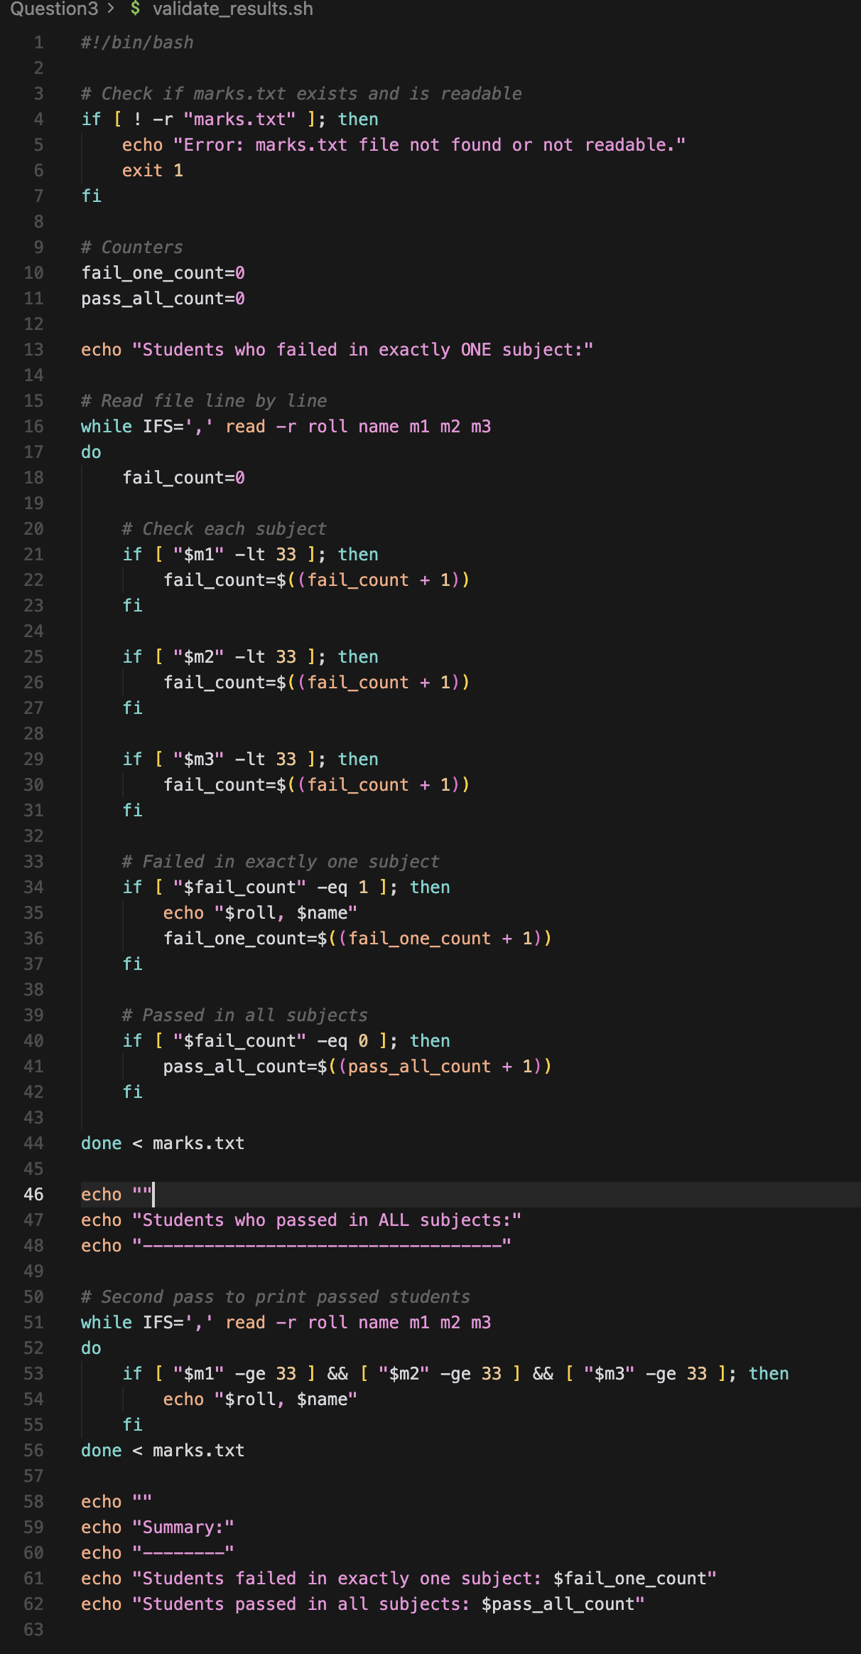
Explanation:
if [ ! -r "marks.txt" ]; then
if : starts a condition
[ ... ] : test cmd
-r : checked if file is readable
! : Not operator
marks.txt: file name
while IFS=',' read -r roll name m1 m2 m3
while : loop that run till the condition is false
IFS=',' Input field separator
read : read one line
variables receive values
roll : roll number
name: Student name
m1,m2,m3 : Marks
do : starts the loop body
fail_count= 0
counter for this student
if [ "$m1" -lt 33 ]; then
-lt : less than
check if marks 1 <33

ail_count=$((fail_count + 1))
Arithmetic operation
Increases failure by 1
Same logic for other condition

while IFS=',' read -r roll name m1 m2 m3
Starts a second loop
used only to print names of students who passed all subjects
In conclusion: The script reads student records line by line using a while loop, counts failed subjects using arithmetic operations, and categorizes students based on pass/fail conditions.
Output:
